Production Planning and Execution (PP) Case Study

标题/题目：生产模块 实战模拟/情景模拟
- 部门/姓名：第 03组；南京大学潘羽 东南大学郭超政
- 日期/联系方式：2018-07-13 panyuyuyu@outlook.com gchaozheng@163.com

提醒：使用GBI2.4实验手册！
注：要将报告三要素：①②③改为自己的相关信息
重要提示: 1, MM/SD/PP 使用同一“个人代码”；
- 个人代码###:( 032 )
2，抄袭/拷贝实验报告，没有成绩

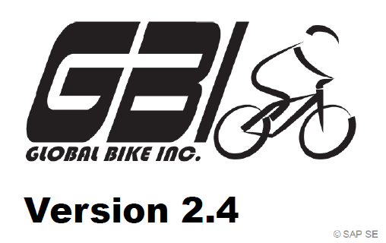

After you have successfully worked through the PP CASE STUDY,
you should be able to solve the following task on your own.

Scenario/ 生产业务“实战模拟”案例背景

Scenario In this PP Process, you should ①in order to create sales and operations plan (SOP) 创建销售规划 for the product group (product family) Mountain bikes or named Off Road Bike (ORMN1### 男款和 ORWN1###女款), take into consideration that the materials of the product group have to be assigned to the strategy group 为该产品组物料补充计划参数, and change the product group to Men’s Off Road Bike 55%, and Women’s Off Road Bike 45%. Therefore, ②enter manually the following sales figures: 手工输入以下销售预测（从当前时段+2开始，因此省略预测环节）

No | Period当前时段+2开始 | Sales (volume)销售预测
1 | Current month + 2 | 150
2 | Current month + 3 | 175
3 | Current month + 4 | 200
4 | Current month + 5 | 85
5 | Current month + 6 | 90
6 | Current month + 7 | 115
Note: As Target day’s supply enter 5 for each forecasted period (total of 6 months)

In addition, you ③receive goods in inventory for Material ORMN1###，为男款物料补充库存。
in order to receive goods in inventory, to find out the required materials for ORMN1###, you need to take a look at the BOM先查看男款物料清单 via transaction使用交易码 CS03. Transfer the required materials to the Enter Goods Receipts: New Item screen. For the Off Road Aluminum Wheel Assembly (ORWA1###) enter SF00 (Semi-Fin. Goods) and for all the other materials RM00 (Raw-Materials) as Storage Location. Enter 500 as Quantity for each material. ④ then ,to finish the following processes as your PP CASE STUDY.

You can use your PP CASE STUDY as guidance since it is based on the same process. However, it is recommended that you solve it on your own in order to test your acquired knowledge

注：请选择“相应模块”，记录业务过程。如有“适当调整”，请做出相应说明。

PP实战模拟/情景模拟，评价参考：
（1）主要步骤“截屏”；（2）记录模块“执行结果”系统信息；（3）适当“文字说明”
以小组为单位（2-3人/不接受个人提交），下课前完成

采用“扣分制”，缺失“扣分点截屏”，扣5分；缺失主要步骤，“酌情扣减”
1，截屏：修改“产品组比例”：70
Men’s Off Road Bike 55%； and Women’s Off Road Bike 45%.
2，截屏：手动输入“销售预测”；75
3，截屏：创建“生产规划”SOP ★： 80
4，截屏：创建“生产订单”/Order Number；85
5，截屏：为男款料补充库存 via transaction CS03, 90
6，截屏：“完工确认”confirmation；92
7，截屏: 男款山地车成本/ Costs for Men’s 68,062.75, 95

注：介于知识点70，85，95之间，酌情
Cost Elements成本要素:（男款）
720000 RM Consumpt Expense 36,211.00
720300 SF Consmpt Expense 29,400.00
800000 Labor 2,451.75
Costs 68,062.75

特别提醒/要求：
1，以“报告三要素”为准；
2，以“原文件名”为准（不要重命名）
3，“截屏”要求使用“局部截屏，全屏截屏扣减
4，在模板相应模块下编辑实验报告（以指定模块为准）

V2.4P363.
Step1,V2.1P265,PP 7: Change Material Master Record 补充物料计划参数
Logistics ► Production ► Master Data ► Material Master ►
Material ► Change ► Immediately
Trans Code/交易码：…MC85….…；部门：….生产部……；身份：…生产部部员.……
截屏：补充计划参数
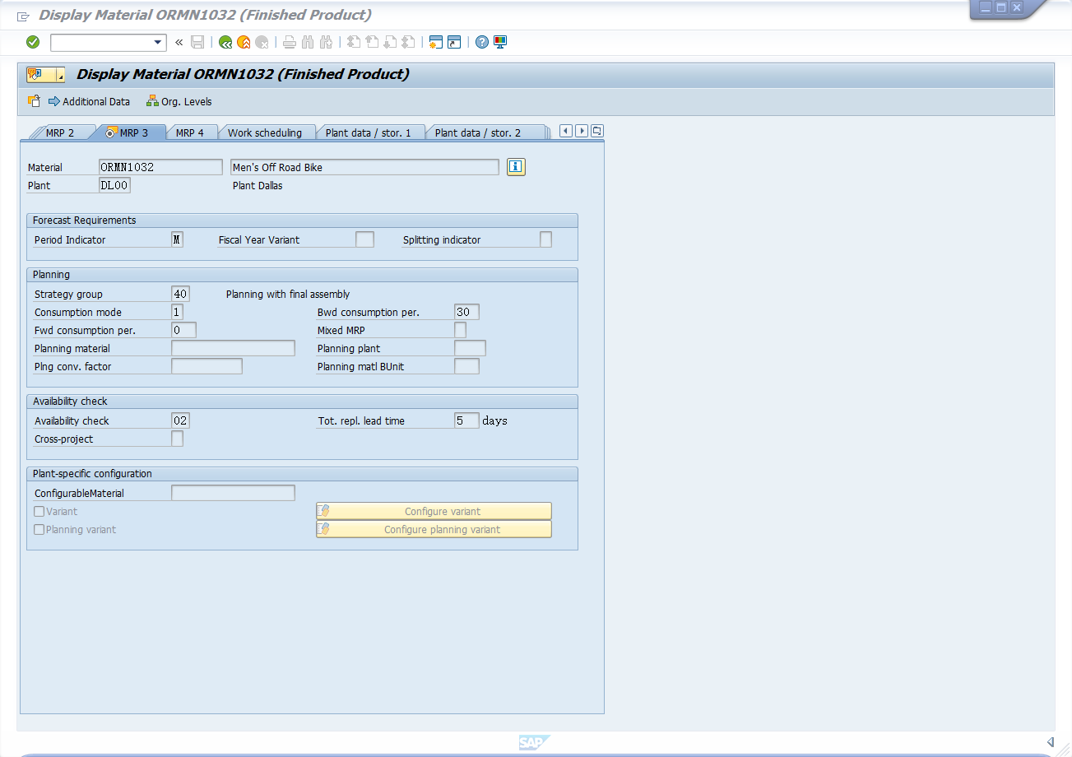

V2.4中PP8与PP7合并！
P267,PP 8: Create Consumption Values for Finished Product 创建销售预测
Logistics ► Production ► Master Data ► Material Master ►
Material ► Create (Special) ► Finished Product
Trans Code/交易码：…….…；部门：….……；身份：….……
在STEP4中，手动输入“销售预测”

V2.4P366.
Step2,P270,PP 9: Change Routing 将加工件分配到工序*（影响执行结果）
Logistics ► Production ► Master Data ► Routings ► Routings ►
Standard Routings ► Change
Trans Code/交易码：…….…；部门：….……；身份：….……

V2.4P368.
Step3,P272,PP 10: Display Product Group 查看产品组
Logistics ► Production ► SOP ► Product Group ► Display
Trans Code/交易码：…MC82….…；部门：…生产部.……；身份：….生产部部员……
1，截屏：修改产品组的比例：70

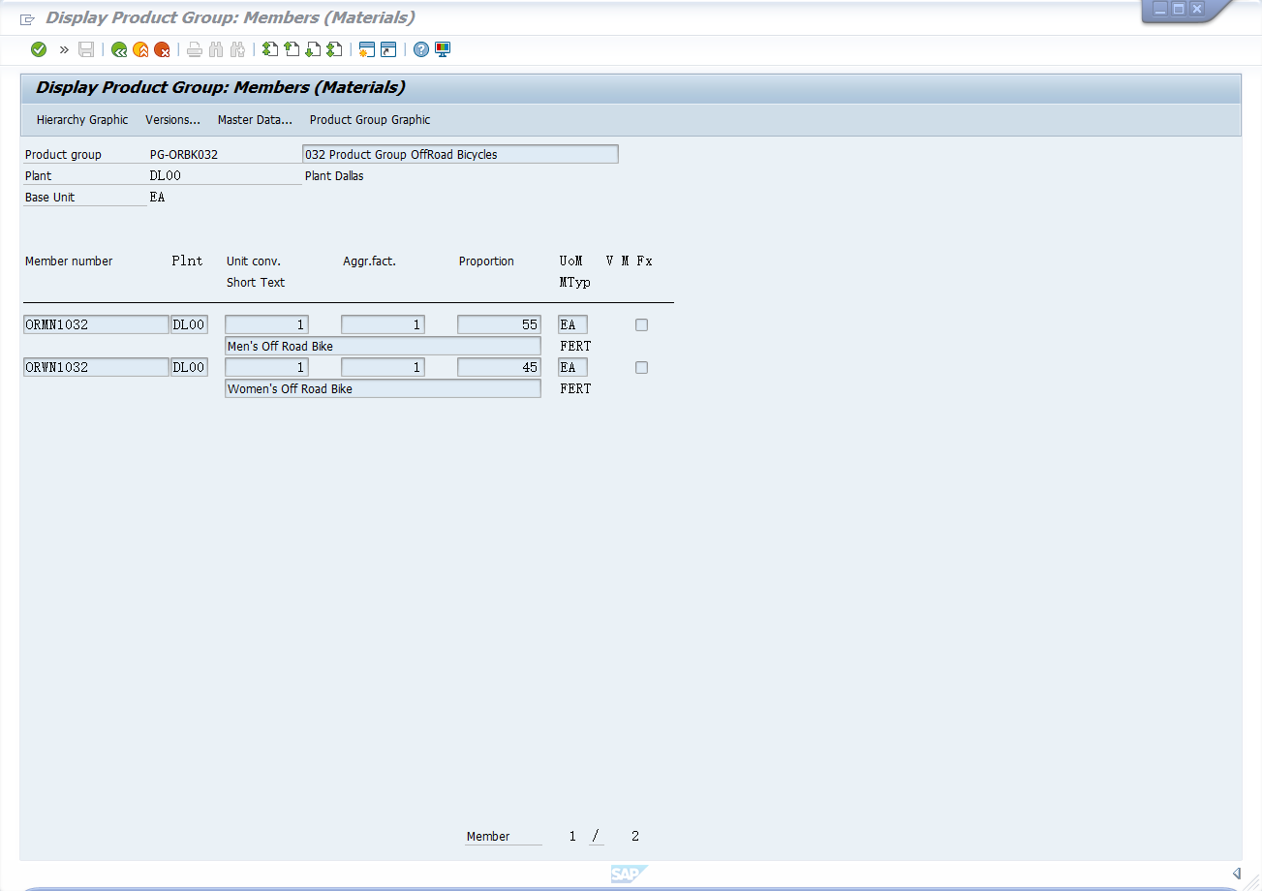

V2.4P370.
Step4,P274,PP 11: Create Sales and Operations Plan ①创建生产规划SOP
Logistics ► Production ► SOP ► Planning ► For Product Group ►
Change
Trans Code/交易码：…MC82….…；部门：….生产部……；身份：….生产部部员……
2，截屏：手动输入销售预测；75
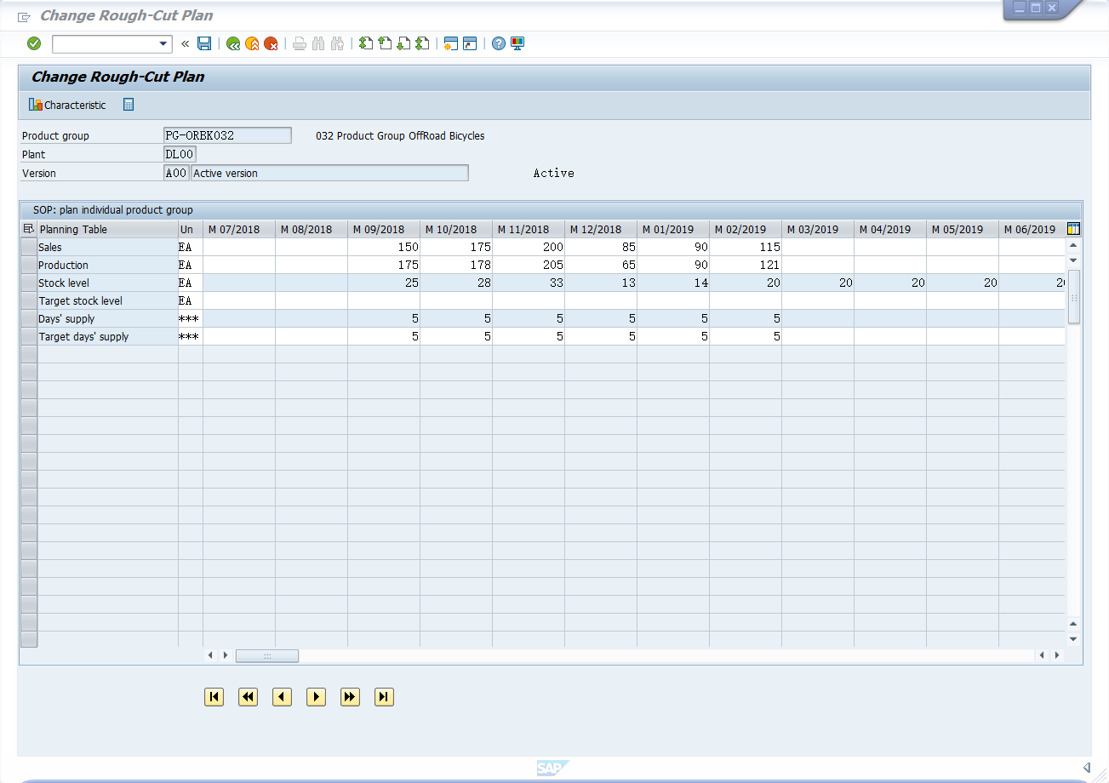

3，截屏：创建生产规划SOP ★： 80
参考答案(受时段影响)
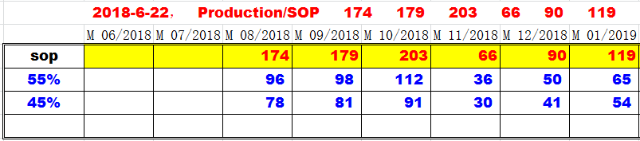

V2.4P374.
Step5,P278,PP 12: Transfer SOP to Demand Management ②创建主生产计划
Logistics ► Production ► SOP ► Disaggregation ► Transfer PG to
Demand Planning
Trans Code/交易码：MC75…….…；部门：生产部….……；身份：…生产部部员.……

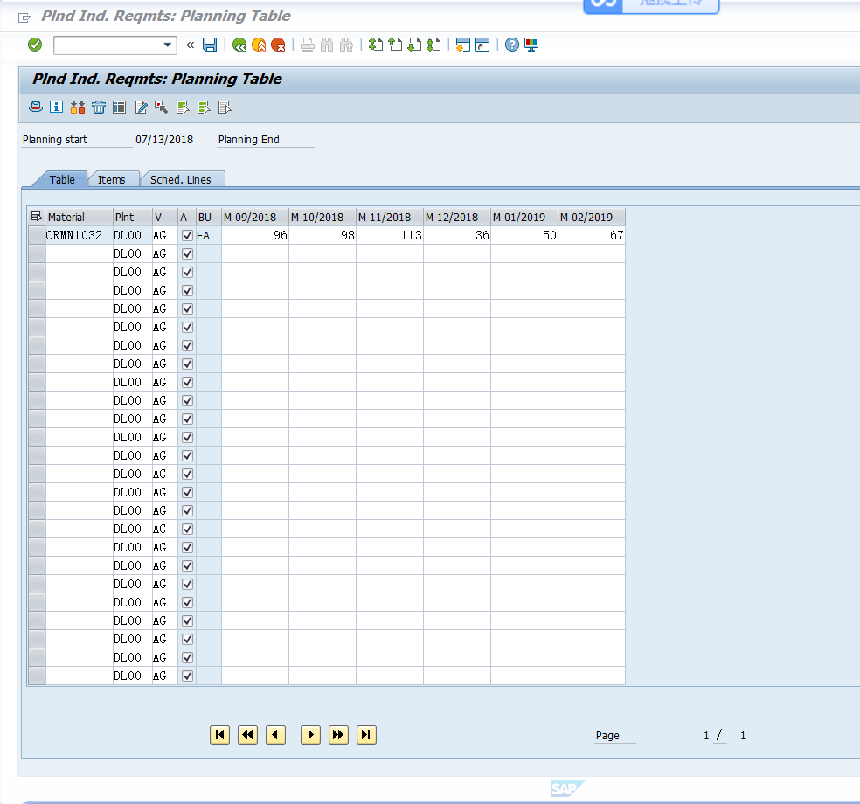

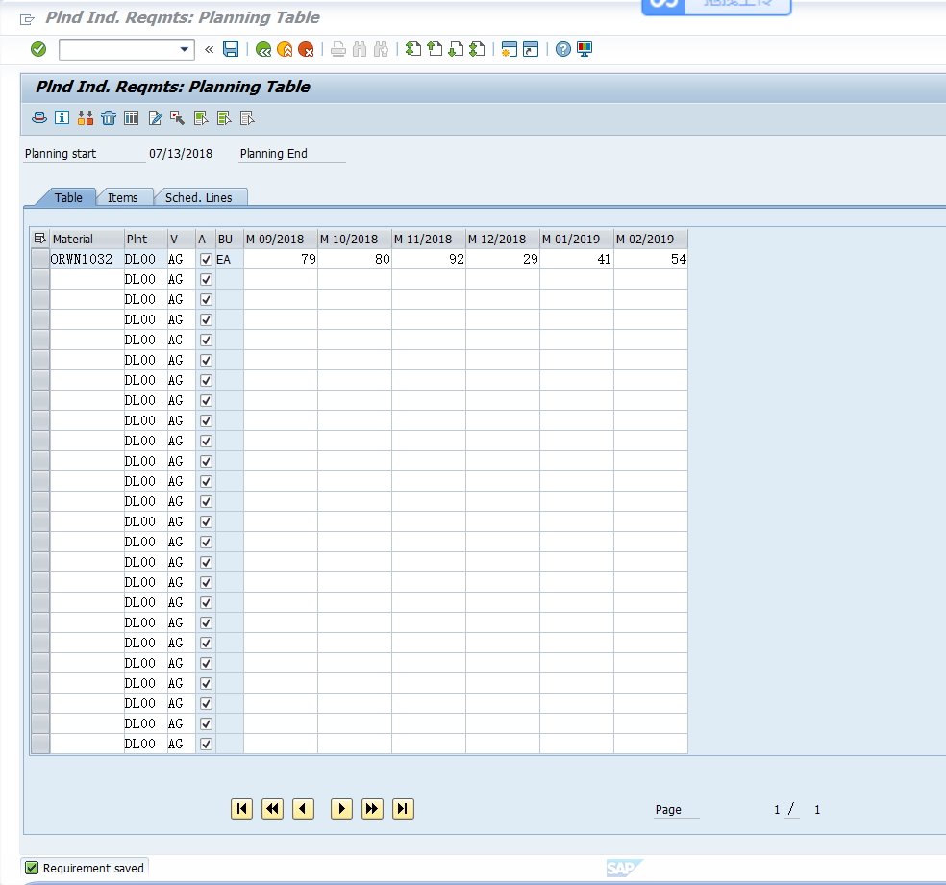
V2.4P376.
Step6,P280,PP 13: Review Demand Management 查看MPS
Logistics ► Production ► Production Planning ► Demand
Management ► Planned Independent Requirements ► Display
Trans Code/交易码：…MD41….…；部门：…生产部.……；身份：…生产部部员.……
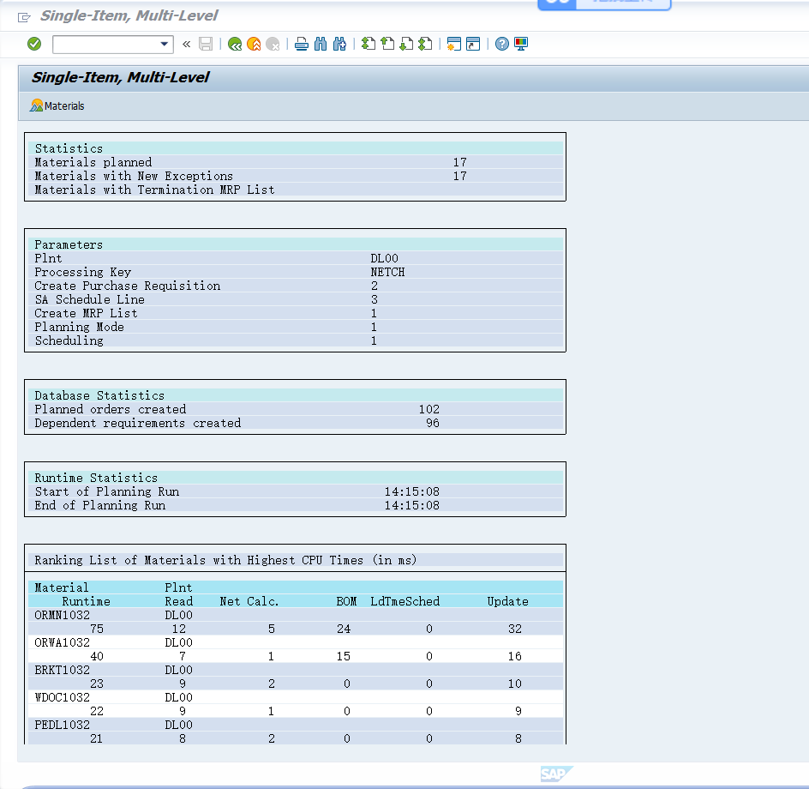

V2.4P378.
Step7,P282,PP 14: Run MRP with MPS ③MRP 创建物料需求计划
V2.1版：Logistics ► Production ► Production Planning ► MPS ► MPS ►
Total Planning ► Online

注：对ORMN1###为男款，做MRP展开
V2.4版P378：Logistics ► Production ► Production Planning ► MPS ► MPS ►
Single-Item, Multi-Level
Trans Code/交易码：…….…；部门：….……；身份：….……

- 以上为“生产计划”流程

- 以下为“生产执行”流程
V2.4P380.
Step8,P284,PP 15: Review Stock/Requirements List 查看库存状态
Logistics ► Production ► Production Planning ► MPS ►
Evaluations ► Stock/Reqmts List
Trans Code/交易码：…….…；部门：….……；身份：….……

V2.4P382.
Step9,P287,PP 16: Convert Planned Order into Production Order ②生产订单
Logistics ► Production ► MRP ► Evaluations ►
Stock/Requirements List
Trans Code/交易码：…CO40….…；部门：….生产部……；身份：….生产部部员……
4，截屏：创建生产订单/Order Number；85
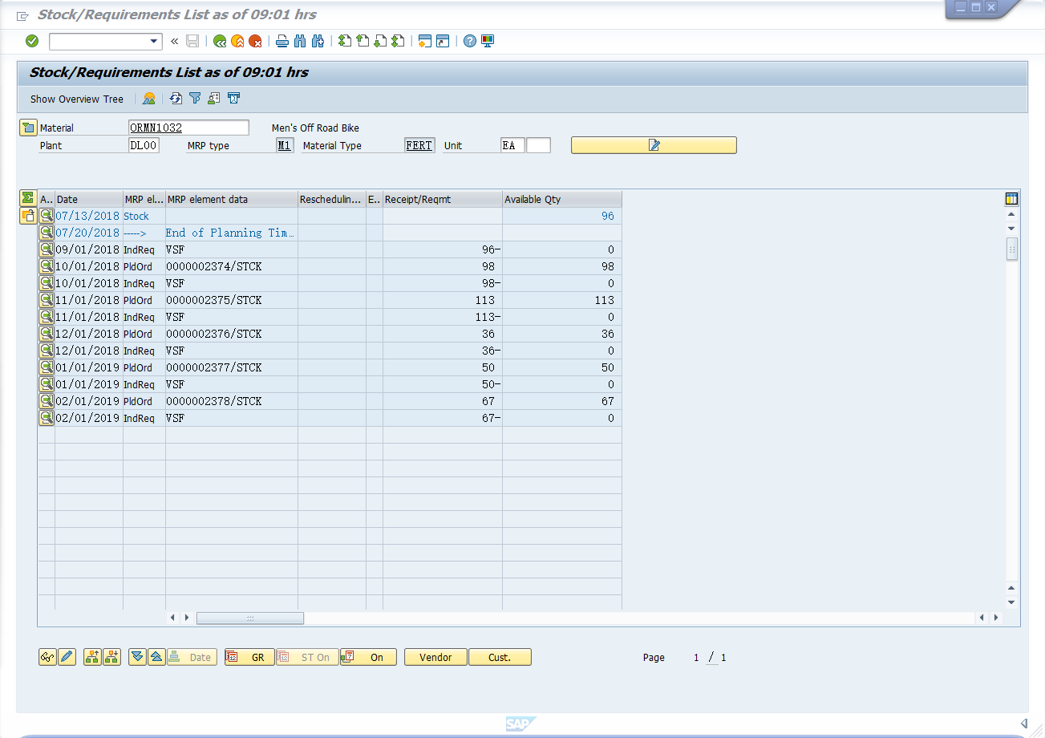

V2.4P384.
Step10,P289,PP 17: Receive Goods in Inventory 补充库存（影响结果）
Logistics ► Materials Management ► Inventory Management ►
Goods Movements ► Goods Receipt ► Other
Trans Code/交易码：……MB1C.…；部门：….物料部……；身份：….库存管理人员……
in order to receive goods in inventory, to find out the required materials for ORMN1###, you need to take a look at the BOM via transaction CS03. Transfer the required materials to the Enter Goods Receipts: New Item screen. For the Off Road Aluminum Wheel Assembly (ORWA1###) enter SF00 (Semi-Fin. Goods) and for all the other materials RM00 (Raw-Materials) as Storage Location. Enter 500 as Quantity for each material.

- 截屏：为男款料补充库存 via transaction CS03, 90

BOM
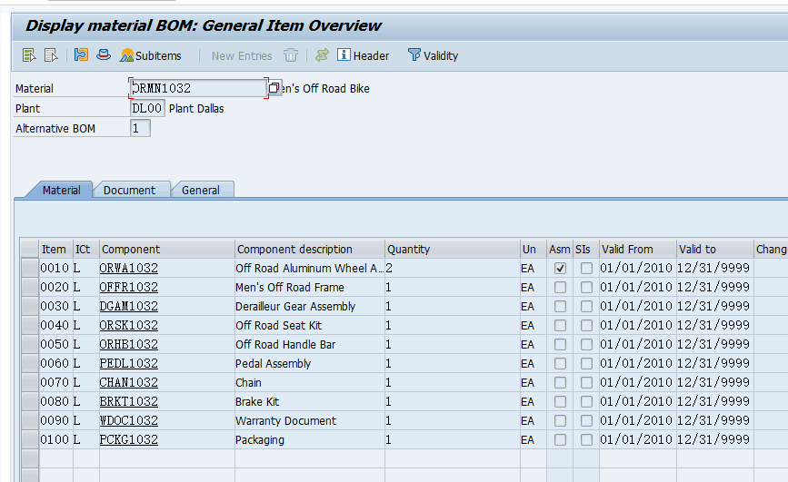

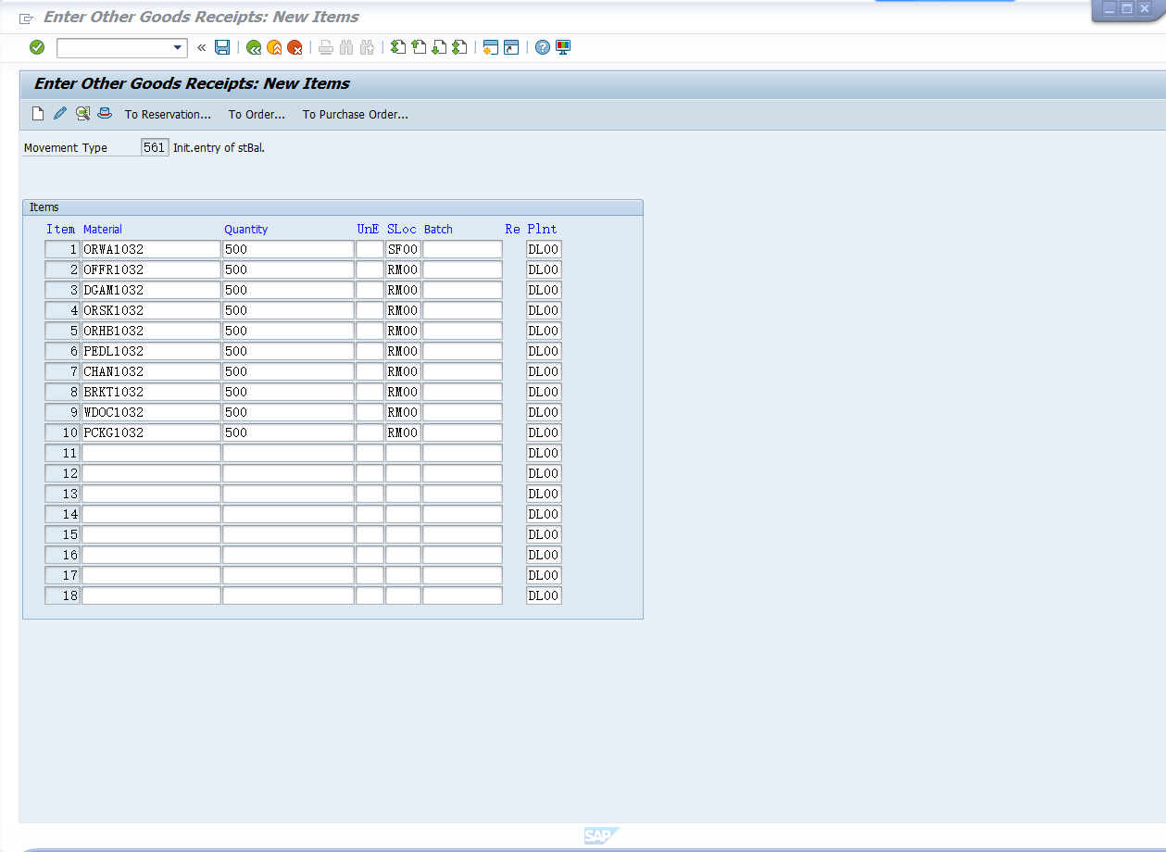

V2.4P386.
Step11,P291,PP 18: Issue Goods to Production Order ④生产发料
Logistics ► Production ► Shop Floor Control ► Goods Movements
► Goods Issue
Trans Code/交易码：…MB1A….…；部门：…物料部.……；身份：…库存管理人员.……
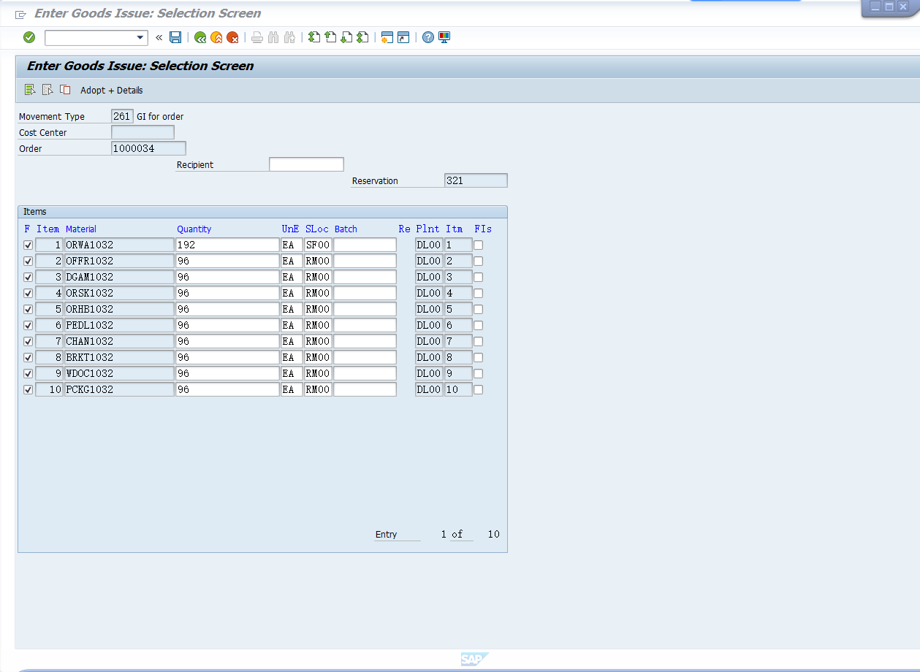

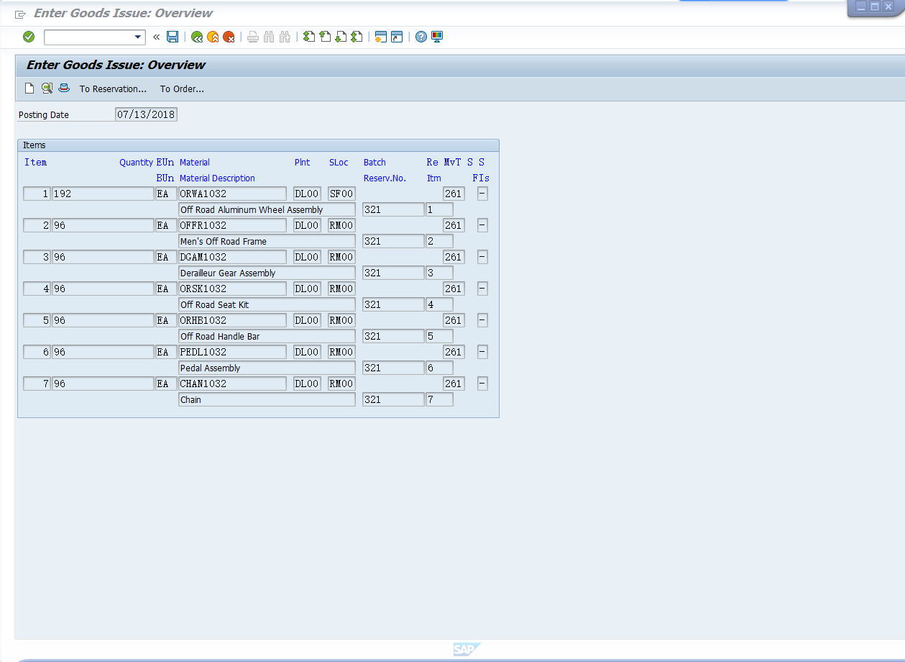
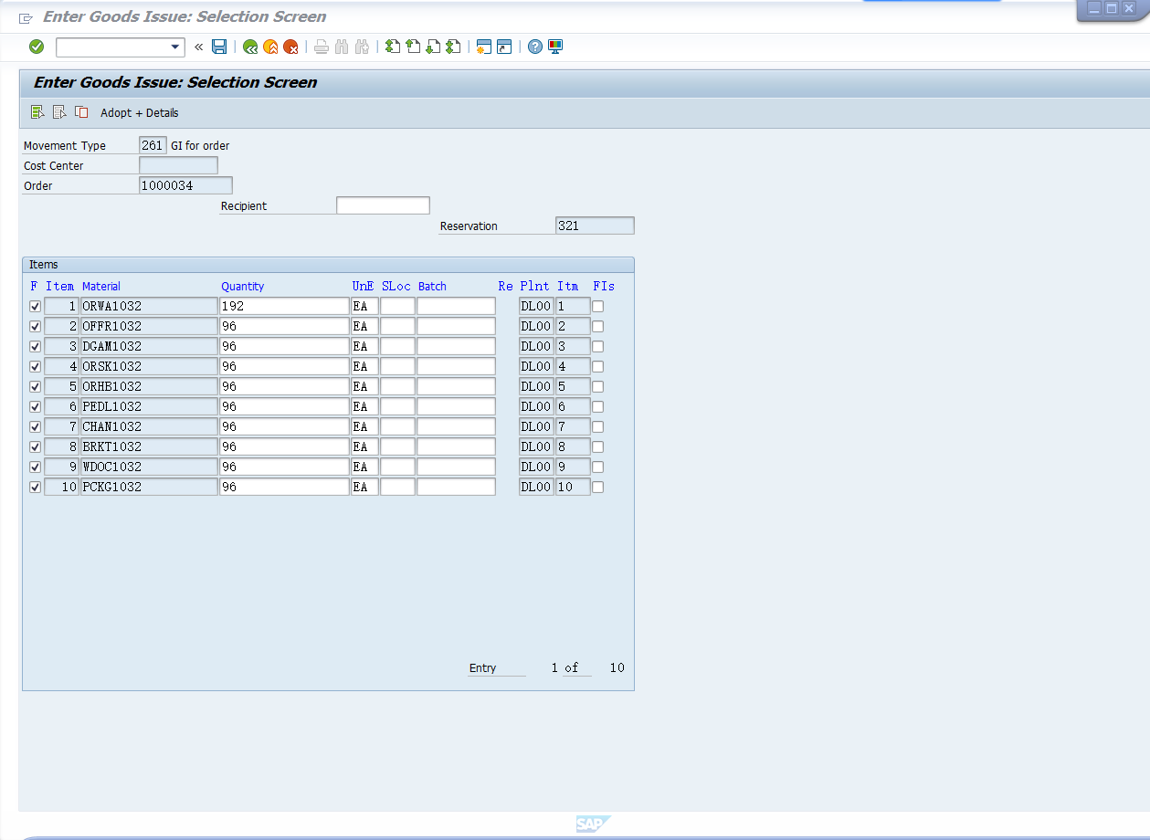

V2.4P389.
Step12,P293,PP 19: Review Production Order Status and Documents
查看生产订单状态
Logistics ► Production ► Shop Floor Control ► Order ► Display
Trans Code/交易码：…….…；部门：….……；身份：….……

V2.4P391.
Step13,P296,PP 20: Confirm Production Completion ⑥完工确认
Logistics ► Production ► Shop Floor Control ► Confirmation ►
Enter ► For Order
Trans Code/交易码：……CO15.…；部门：生产部….……；身份：….生产部组员……
6，截屏：完工确认confirmation；92
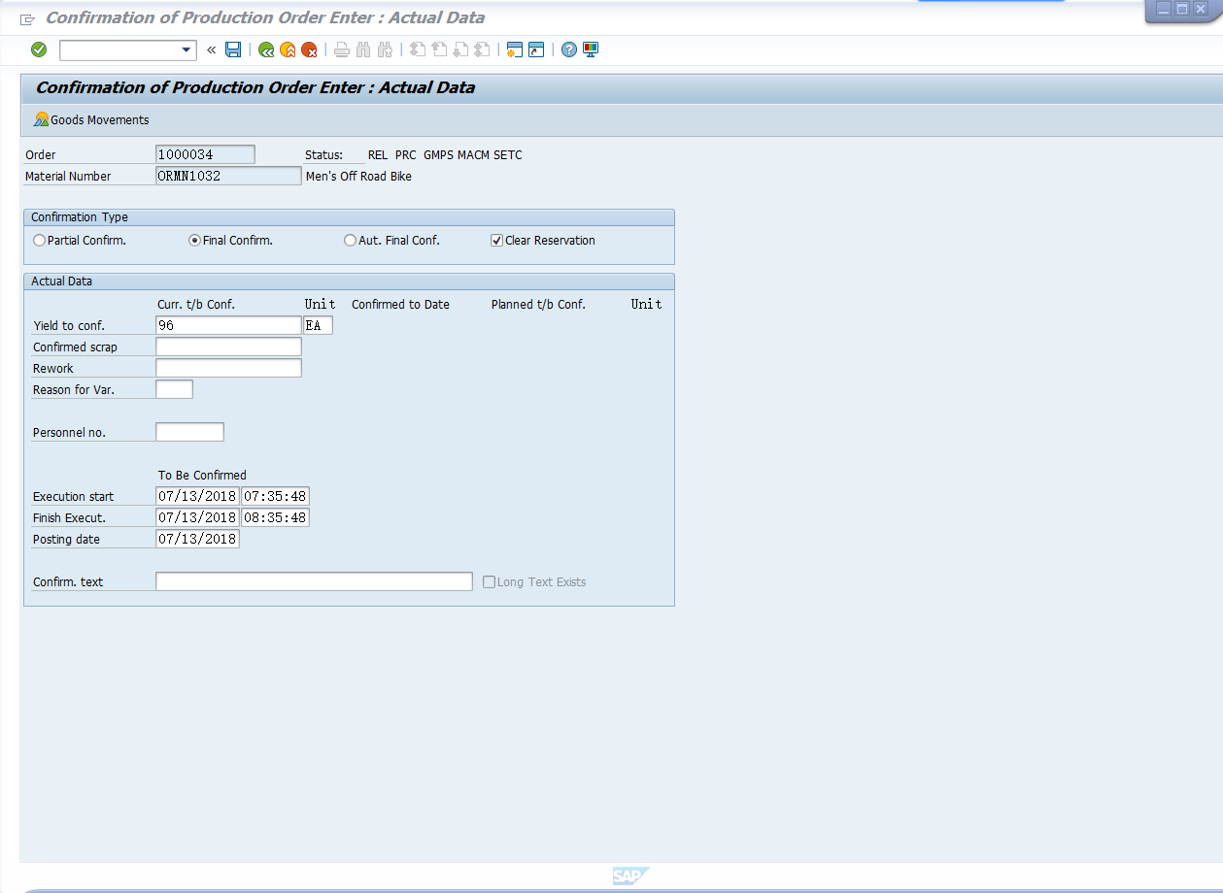

V2.4P393.
Step14,P298,PP 21: Receive Goods from Production Order ⑦生产入库
Logistics ► Production ► Shop Floor Control ► Goods Movements
► Goods Receipt
Trans Code/交易码：…MB31…….…；部门：…物料部.……；身份：….库存管理人员.…………

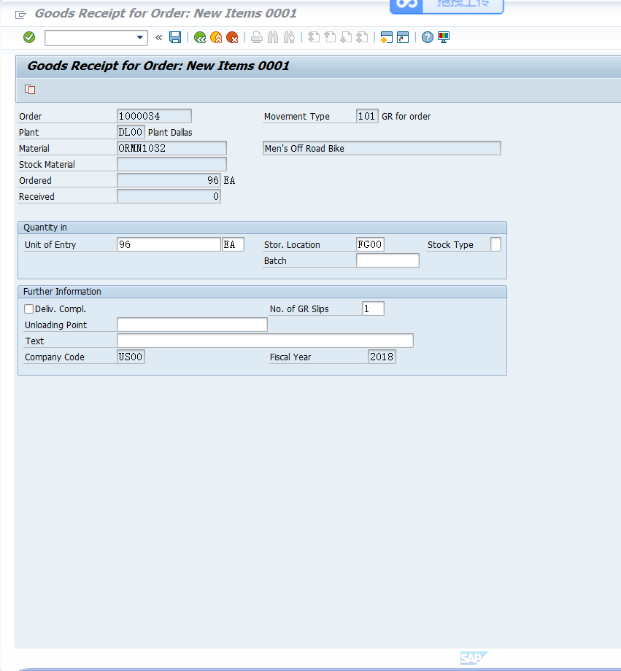

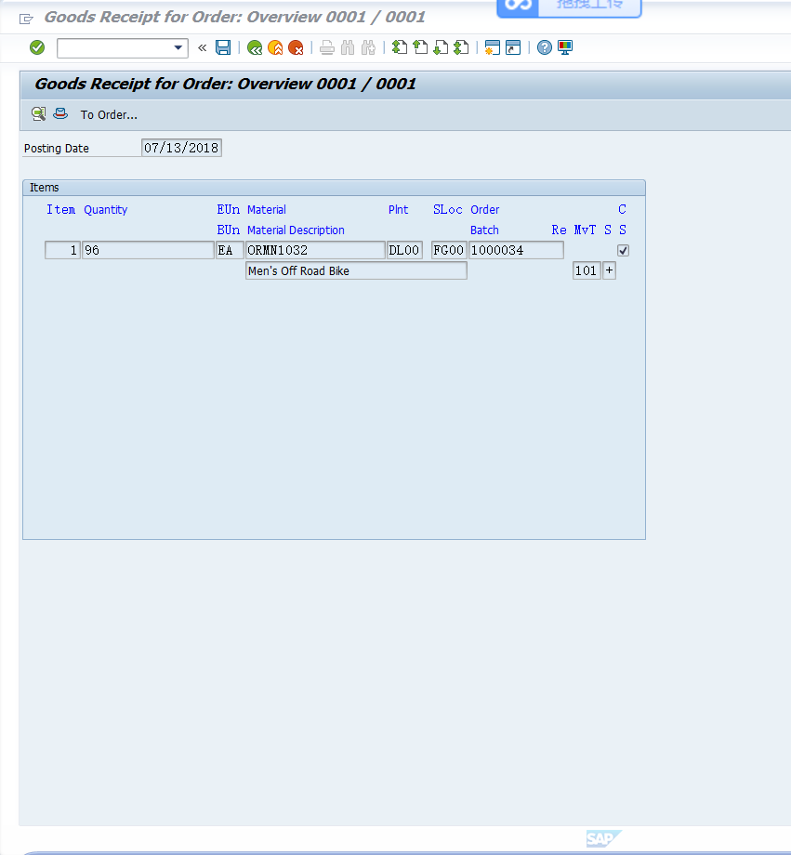

V2.4P395.
Step15,P300,PP 22: Review Costs Assigned to Production Order
查看生产订单成本
Logistics ► Production ► Shop Floor Control ► Order ► Display
Trans Code/交易码：….…；部门：….……；身份：…

V2.4P396.
Step16,P301,PP 23: Settle Costs of Production Order ⑧结算生产订单
Logistics ► Production ► Shop Floor Control ► Period-End
Closing ► Settlement ► Individual Processing
Trans Code/交易码：…KO88….…；部门：…财务部门.……；身份：….财务人员……
7，截屏: 男款山地车成本/ Costs for Men’s 68,062.75, 95

Cost Elements成本要素:（男款）
720000 RM Consumpt Expense 36,211.00
720300 SF Consmpt Expense 29,400.00
800000 Labor 2,451.75
Costs 68,062.75

2018/5/15
参考答案：生产订单1000040
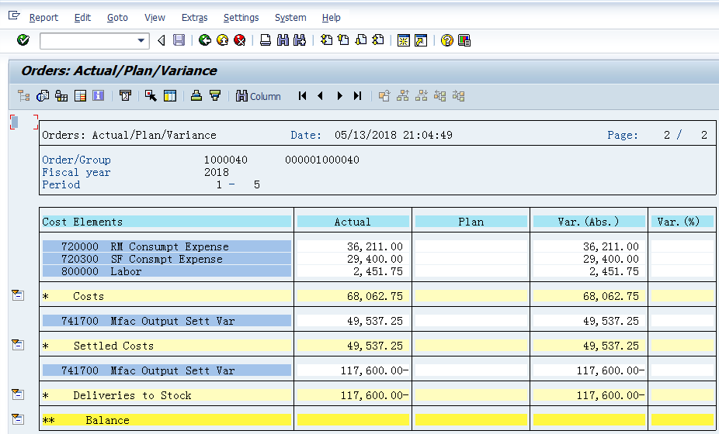

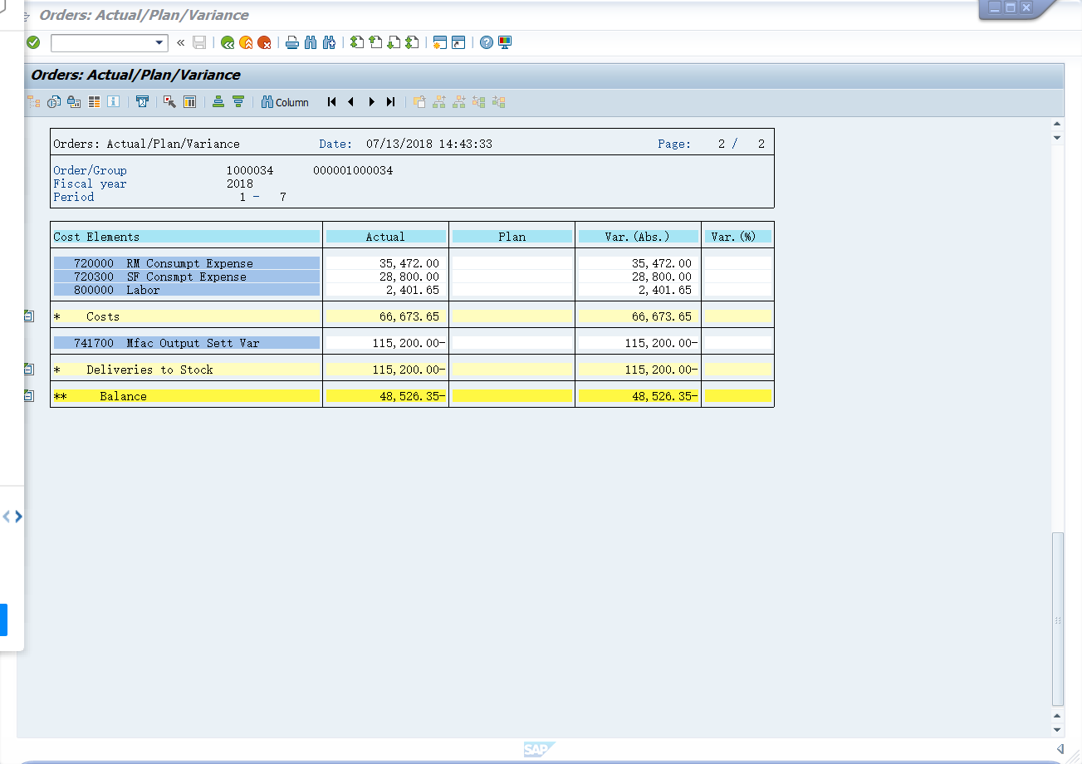

生产模块实验总结/感受：
1、

2、

3、
。。。。。。

